Structure-Based Testing

What is Structure-Based Testing
# Source: AI Source: Provided by: [Data Path: Persons Table -> ID Column: 1, Name_En Column: Motasem Essam] -> From: [ChatGPT] on [8/24/2025]
Structure-based testing is a white-box test design technique where test cases are created based on the internal structure of the code or system implementation.
👉 In other words:
- You look inside the code (logic, statements, branches, paths, conditions).
- Tests are designed to ensure that all parts of the code are executed at least once.
- Goal: increase code coverage and detect hidden defects.

🔑 Characteristics
# Source: AI Source: Provided by: [Data Path: Persons Table -> ID Column: 1, Name_En Column: Motasem Essam] -> From: [ChatGPT] on [8/24/2025]
- Also called white-box techniques.
- Focus on how the system works internally rather than just what it should do.
- Coverage is measured using code metrics (statement coverage, branch coverage, path coverage, etc.).

🛠️ Common Structure-Based Techniques
# Source: AI Source: Provided by: [Data Path: Persons Table -> ID Column: 1, Name_En Column: Motasem Essam] -> From: [ChatGPT] on [8/24/2025]
- Statement Testing & Coverage
  - Ensure every statement in the code executes at least once.
- Decision (Branch) Testing & Coverage
  - Ensure every decision (true/false outcome) is tested.
- Condition Testing
  - Ensure each condition in a decision is tested (true and false).
- Multiple Condition Coverage
  - Ensure all possible combinations of conditions are tested.
- Path Testing
  - Ensure all possible execution paths are tested.
- Data Flow Testing
  - Ensure variables are properly defined, used, and cleared in the code.

📖 Example
# Source: AI Source: Provided by: [Data Path: Persons Table -> ID Column: 1, Name_En Column: Motasem Essam] -> From: [ChatGPT] on [8/24/2025]
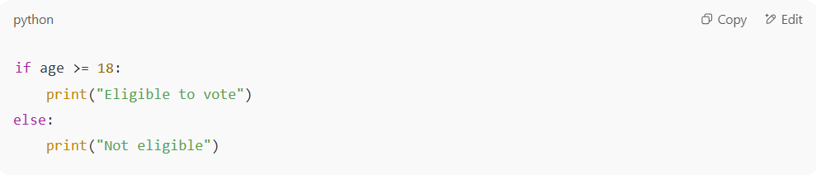
Code fragment:
if age >= 18:
print("Eligible to vote")
else:
print("Not eligible")

Specification-based test (black-box):
- Test with inputs: 17, 18 → check expected output.
Structure-based test (white-box):
- Ensure both true branch (age >= 18) and false branch (else) are executed.
- Coverage goal: 100% branch coverage.

✅ Benefits
# Source: AI Source: Provided by: [Data Path: Persons Table -> ID Column: 1, Name_En Column: Motasem Essam] -> From: [ChatGPT] on [8/24/2025]
- Increases confidence that all parts of the code are tested.
- Detects hidden logic errors not visible from requirements.
- Gives measurable coverage metrics.

⚠️ Limitations
# Source: AI Source: Provided by: [Data Path: Persons Table -> ID Column: 1, Name_En Column: Motasem Essam] -> From: [ChatGPT] on [8/24/2025]
- Requires knowledge of code (tester must understand programming).
- Can miss defects related to missing requirements (since it only tests what is implemented, not what should be).

is Structure-Based Testing is same White-Box Techniques

1. Structure-Based Testing
# Source: AI Source: Provided by: [Data Path: Persons Table -> ID Column: 1, Name_En Column: Motasem Essam] -> From: [ChatGPT] on [8/24/2025]
- A category of test design techniques.
- Focuses on designing tests from the internal structure of the code.
- Examples:
  - Statement Testing & Coverage
  - Decision (Branch) Testing
  - Condition Testing
  - Multiple Condition Coverage
  - Path Testing
  - Data Flow Testing

2. White-Box Techniques
# Source: AI Source: Provided by: [Data Path: Persons Table -> ID Column: 1, Name_En Column: Motasem Essam] -> From: [ChatGPT] on [8/24/2025]
- A broader term for any testing approach where you look inside the system’s internal implementation.
- White-box includes structure-based testing but can also include things like:
  - Code reviews & static analysis (not execution-based tests).
  - Unit tests written by developers to cover code internals.
  - Security code analysis (checking for vulnerabilities).

🔄 Relationship
# Source: AI Source: Provided by: [Data Path: Persons Table -> ID Column: 1, Name_En Column: Motasem Essam] -> From: [ChatGPT] on [8/24/2025]
✅ All Structure-Based Testing = White-Box Techniques
❌ But not all White-Box Techniques = Structure-Based Testing
Why? Because white-box is the big umbrella, and structure-based is the test design part inside it.

📊 Example
# Source: AI Source: Provided by: [Data Path: Persons Table -> ID Column: 1, Name_En Column: Motasem Essam] -> From: [ChatGPT] on [8/24/2025]
- White-box in general:
Developer checks cyclomatic complexity, runs static analysis tools, or writes unit tests.
- Structure-based (subset):
Tester designs test cases to cover every branch and path in the code.

⚖️ Final Answer
# Source: AI Source: Provided by: [Data Path: Persons Table -> ID Column: 1, Name_En Column: Motasem Essam] -> From: [ChatGPT] on [8/24/2025]
👉 Structure-Based Testing is a type of White-Box Technique.
So they are not exactly the same, but structure-based belongs inside white-box techniques.

⚖️ Final Definition
# Source: AI Source: Provided by: [Data Path: Persons Table -> ID Column: 1, Name_En Column: Motasem Essam] -> From: [ChatGPT] on [8/24/2025]
Structure-Based Testing = designing tests from the internal structure of the code (statements, branches, paths, data flows), aiming for maximum code coverage.

